Java try-catch->

## **Java try block**

Java try block is used to enclose the code that might throw an exception. It must be used within the method.

Java try block must be followed by either catch or finally block

Syntax of java try-catch

try{

//code that may throw exception

}catch(Exception_class_Name ref){}

#### **Syntax of try-finally block**

1. **try**{
2. //code that may throw exception
3. }**finally**{}

## **Problem without exception handling->**

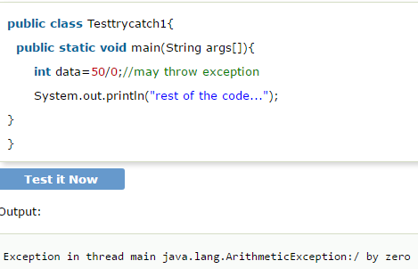

As displayed in the above example, rest of the code is not executed (in such case, rest of the code... statement is not printed).

There can be 100 lines of code after exception. So all the code after exception will not be executed.

## **Solution by exception handling->**

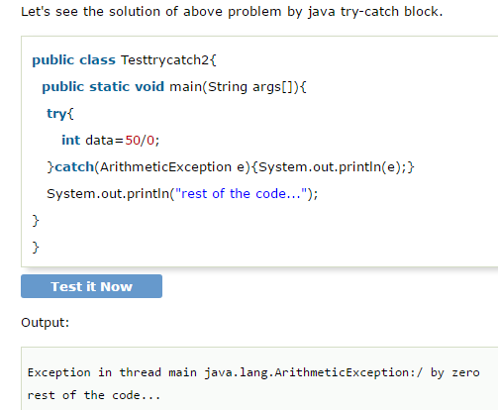

## **Internal working of java try-catch block->**

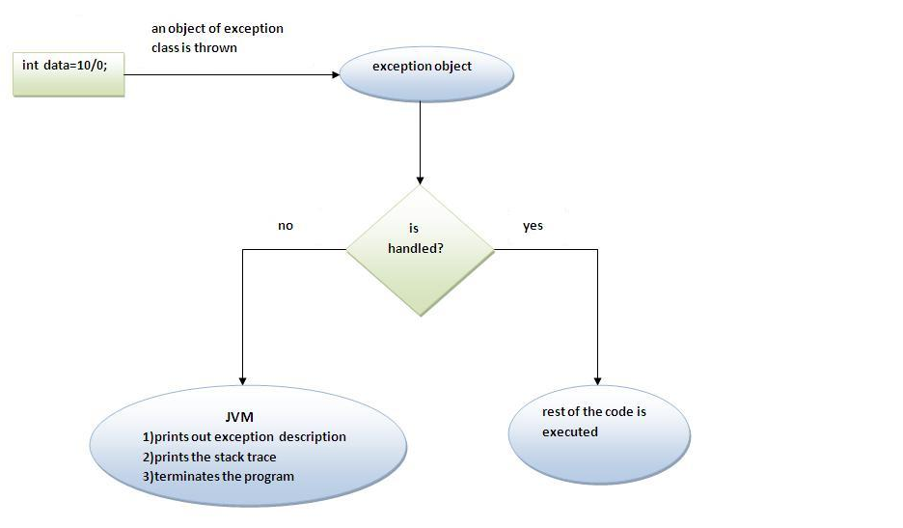

*The JVM firstly checks whether the exception is handled or not. If exception is not handled, JVM provides a default exception handler that performs the following tasks:*

* *Prints out exception description.*
* *Prints the stack trace (Hierarchy of methods where the exception occurred).*
* *Causes the program to terminate.*

*But if exception is handled by the application programmer, normal flow of the application is maintained i.e. rest of the code is executed.*